1. **Method**

The method used in this project is the V-Model method with the main structure shown in the following picture.

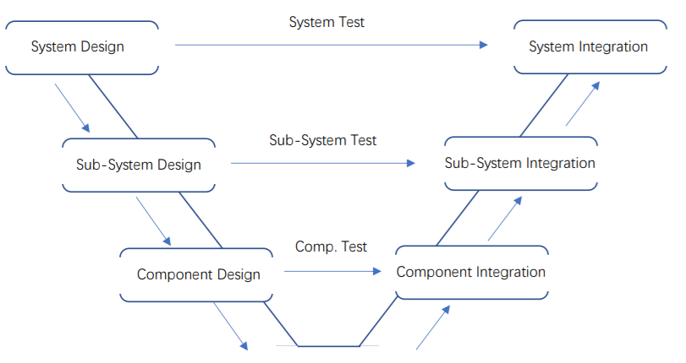

V-Model can be divided into two main phases: ‘Design Phase’ and ‘Integration Phase’.

In the Design Phase, the behaviors and edges of the final product should be decided and evaluated. In the Integration Phase, focus lies on assembling components, verifying designs in Design Phase and realizing the final product.

The core of V-Model is operating tests and verification. There are several progressive layers in both phases from system to sub-system to component. In the Design Phase different test plans are designed and outputs from different layers and tests are operated in corresponding layers in the Integration Phase which can realize the verification of design.

1. **Reasons of choice**

In this propulsion system design project, there is a clear final product idea (fixed component composition, fixed working principle) which gives the team chances to optimize the same idea and guarantee a better functionality of the result. Especially for this particular propulsion system, every component in every sub-system has closely connections and plays different essential roles in the process of generating thrust (components or sub-systems are all related to energy input, output and transmission). An iterative method is needed to verify and validate the function and property of the

components themselves and the accurate relationship between different sub-systems repeatedly.

Because every part of the calculation chain has a close connection to each other, we must make sure that the relationship between every part is correct. We must recall and check if there are errors in previous parts before starting a new part. This regularly means going backwards checking for mistakes is necessary. Compared with other methods, the progressive layers of V-Model make sure that that the problem and its direction will be recalled and changed effectively. The team can ensure the error sources and make targeted improvement easily.

1. **Usage of method**

Firstly, team has to make the system overview. In order to figure out how system works, disassembling the main system into sub-systems and into components is needed. For every layer, a system description, sub-system descriptions or component descriptions should be taken as the start of the layer. All these descriptions should contain all variables which are related to the input and output of the systems or components. According to these descriptions, the reactions within systems and components can be known and vague elements can be eliminated.

From the system and component descriptions, the design concepts and test plans can be created. In main system layer, tests will be designed to show the working state of system such as working efficiency and thrust generated by whole propulsion system. In the sub-system layer, tests will be designed, proving relationships between certain sub-systems. For example, the energy transmission/consumption and the power transmission system. In the component layer, the calculation chain will be designed. Tests will be designed to find out the characteristic of every component such as the relationship between the number of gear teeth and the rotation speed.

After finishing all the designs, the components should be reassembled into sub-systems and into system. The test results from deeper layers will be used in tests from shallower layers. All designs can be validated. When errors appear, the error sources can be found in corresponding deeper layers.

The following list show the deliverables of every phase and layer:

|  |  |
| --- | --- |
| Layer | Deliverables |
| Design Phase | |
| System Design | 1. Present system description 2. New system design plan 3. System working state test plan |
| Sub-System Design | 1. Present sub-system descriptions 2. New sub-system design plans 3. Sub-systems relationship test plans |
| Component Design | 1. Present component descriptions 2. New component compositions design plans, 3. Component working characteristic test plans 4. Calculation chain design plan 5. Calculation chain verification test plan |
| Integration Phase | |
| System Integration | 1. Results of working state of present and new system test 2. Feasibility evaluation result of new system by comparing with present system |
| Sub-System Integration | 1. Results of present and new sub-system relationship tests 2. Feasibility evaluation results of new sub-systems by comparing with present sub-systems |
| Component Integration | 1. Results of present and new component working characteristic tests. 2. Feasibility evaluation results of new components by comparing with present components 3. Final calculation chain |